Adventure Part 3

# Recap

You start your adventure recapping all that has happened the last few days. In Silver Rose, Elena met a beautiful Rogue named Kallista who sold her a lock picking kit and taught her how to pick simple locks.

Vahalla met a hauntingly beautiful Bard named Ella, who seemed enchanted by Vahalla. Vahalla also meat the Talos Priest, Taoba.

You all met the weaponsmith, Rejak.

Together, you helped rid Silver Rose of a Wererat who was forcing orphan children to steal. Both Nosaj and Vahalla were bitten.

You returned a relic to Toaba, gaining some favor with the god, and a hammer to Rejak, who gave you items. Additionally, you saved 10 orphan children who will now live with David and Mary Margaret.

Your adventure took you north to Serenity Gardens. However, you were stopped by vicious Rosemars. An adorable Pixie, Basil, saved you and invited you back to her village at a later time. You continued North, resting at Serenity Gardens, before heading into the Temporal Forest.

In the forest, you found a haunted mansion. You fought animated armors, shadows, doppelgangers, a Ghoul who was formally Lucy, and a human Rouge Jade, who belongs to a Vampire whose name you did not ask for.

Among other things, you received a large egg that seems alive but could use some care, several magical weapons. Additionally, you received sending stones to communicate with Jade if needed. Finally, Vahalla’s scrapped arm does not seem to be healing and has mushroom growth coming out of it.

# Outside the Mansion

The temporal forest is booming with life. It is mid-morning and the canopy is just thin enough where you’re at that the sunlight is leaking through, creating magical rays of light that dance through the forest. In the distance, you see fawns frolicking through the trees and can hear frogs croaking happily out of sight.

Elena notes that you are about half a day’s walk from Thels Dorei. The walk itself is very pleasant but uneventful. A few creatures in the forest consider trying their luck at having your party as lunch, but fortunately decide on finding a weaker target.

# Thels Dorei

A large brush is standing sentry in front of you. Elena, unphased, walks straight through it. Your party follows. On the other side of the brush, a magical city lies before you.

**Play Music**

The city is completely made from nature, perfectly complementing the natural world that has grown around the city. Thels Dorei is ancient, one of the first elven communities in the land.

Some small wooden houses decorate the forest floor while others clingy proudly to the trees. Spiral stair cases wrap up the incredibly thick oak trees and wooden bridges swing above you and connect the homes. The trees and moss and grass come in every shade of green. The beaten paths around Thels Dorei are lined with blue, purple and white mushrooms that glow brilliantly and light the path, day and night.

Eleven children run carefree through the village, chasing butterflies. Young elven boys and girls dance majestically to the most enchanting music you’ve ever heard. Adult elves walk purposefully through the town, only briefly minding your intruding party.

Nosaj notices a pungent bitter odor coming from the mushrooms.

Vahalla’s arm is completely numb and the fungi growth is spreading to her forearm. Small mushrooms of various colors protrude from her skin. She can rub them off, but they grow back quickly.

Everyone is aghast by the smell coming from Nosaj (from jumping into the cesspool in the mansion). Elena points to a river that flows through the city. She says to follow it to the end and he’ll find a public bathing area.

**What do you do?**

## Stores

There are not a lot of stores. The stores that are there mostly sell food, wine, crafting materials, and stuff for spells. Additionally, there is a book store (most stuff is in elvish) that you can learn tool skills from. Potion store as well, but only basic stuff.

Twist, they don’t take money. You must trade them or do a service for them.

## Medicine Man

If you go to the medicine man about Vahalla’s arm, he tells you that he recognizes the fungus and recommends you cut off your arm. He says if you hurry to the Myconid Community, they may have a cure for it.

He gives you a map to the underdark entrance

## Find Ayana

As you ask around about Ayana, the Adult elves will not speak with you. They are very displeased by Valhalla’s presence/her arm

The children don’t know to care. They tell you that Ayana is the daughter of Elder Kastor, the leader of Thels Dorei. The children point at a particularly large wooden house at the base of a giant and ancient tree.

The hut is huge and part of tree has been carved out to allow for even more room. At the back of the entry way, a wooden throne rests, covered in decorative twigs and leaves. Upon the throne a very old elf resides. His copper skin has dimmed in luminance, his once chestnut hair containing strands of white. It is obvious this elf is nearing the end of his long life.

Nasoj notices a particular smell coming from the man. He smells…like an elf. Something Nasoj had never noticed before.

He asks why you’re in his village.

He is very distrustful of you and questions you extensively.

i.e.: How do you know Ayana. How did you get that ring? Why are you brining the ring back/why do you care? Who are you? Why did Elena come back? Why are you with a demon?

He finally believes you and informs you that Ayana is his only great great granddaughter is not in the village. She has been kidnapped by meddling dwarves in the new settlement, Mt. Condor.

He has sent his best soldiers to retrieve her. However, most of his best men had fallen when the attacks (undead attacks) began so he currently does not have anyone who is capable of venturing out to the mountains and brining her back safely, regardless of the reward he offers.

### Loot

* Staff of the Python (Druid, Cleric or Warlock only) (requires attunement)
  + Throw on ground and will turn into Giant constrictor snake
  + Must say command word
  + Mentally command snake within 60 ft
* Javelin of Lighting
  + When thrown and say command word, it turns into into a lighting bolt up to 120ft.
  + Javelin damage + 4d6
* Bracers of Archery
  + Gives proficiency in bows
  + +2 to damage rolls with archery weapons
* Manual of Bodily Health
  + Talks about health and diet tips
  + Read for 48 hours within 6 days or less and Const score +2 (not mod)
  + Maximum for Const +2 (not 20 anymore, but 22)
  + Loses magic but can be reused in 100 years.
* 50gp (all they have)

He says a reward will be available to any party who procures the safe return of Ayana and her baby, if they are now separate. He doubts 2 half elves will be able to do the job, however, if true elves were unable to.

He asks you to leave his home as he has work to do. You leave.

Nosaj passively notices a unique smell coming from Vahalla.

Vahalla looks down at her numb arm and realize she is carrying a stick. She doesn’t recall picking it up.

## The Tiefling

A young girl elf who was never bothered by Elena’s half human blood tells you she remembers a Tiefling coming through the village a few years back…

The girl was headed to Murkland, she recalls, and was incredibly angry about something. She only stayed in the village one night, but she got into a fight with some of the younger elven warriors. They were hurt pretty badly…

## The Owl

If you specifically ask a female elf about the egg, she will identify it as a giant owl egg. She tells you they are no good in combat, but are very smart and loyal, and will imprint on the first creature they see when they hatch. It is very rare to find an owl egg, as great owls only make their nests in places that almost no other creature would be able to get to. She offers to buy it for 10gp. It looks like it is discolored though. Most giant owls are brown and white (barn owls) and their eggs are white with blueish speckles…This one may be different as the egg is light gray with the sparkles.

## Storage

Your bags are getting heavy with loot (excluding Vahalla who has a bag of holding). You are unsure if you can carry all of this to the mountains and back down, especially if Ayana needs help.

Add in more stuff about Vahalla’s arm having a mind of its own as the mushrooms grow deep into her arm.

The walk to {myconid’s or Mt Condor} is uneventful. You do notice quite a few broken branches and footprints in every direction, but it looks like the creatures have passed by now.

# Save Valhalla - Myconid

The entrance to the cave is vast and dark. The smell of fungus lingers at the mouth. You are in the right place.

As you travel through the cave, amongst the moist stalagmites and stalactites, your path is illuminated by the same glowing mushrooms found in Thels Dorei. As you continue, the stench of compost becomes even stronger, while the luminance of the mushrooms begins to extend to mold that is growing on the cavern walls. The bioluminescent glows blue, pink, purple, yellow, and green. It is strangely beautiful.

A small wooden fence extends the width of the cavern. It is more of a guidance on where the Myconid circle begins, rather than a barrier to protect the community. A wooden gate resides unlocked in the center of the fence.

As you enter, you begin to notice large mushrooms of various shapes and bright colors roaming the cavern. They seem excited by your presence.

**What do you do?**

The Myconid immediately recognize the fungus growing on Valhalla. They tell you that she has the spore of a dark Myconid circle. Most spores will only re-animate the dead to help out in the circle, but the dark Myconids have found a way to control the living as well. They cannot guarantee if it’ll fully heal or not. They quickly offer to help but will need some time to make the remedy. They ask if you’d like to wait?

**What do you do?**

They say the will start right way. As they are talking to you, they talk about these spiders that have been imposing on the Myconid circle. They are not sure why they are coming around, but they have been a problem.

**Option Adventure: Gibber Mouther**

You fight your way through the caverns and fight at least a dozen spiders (depending on if Taylor and Williams is/are there). At the end, you see a Gibbering Mouther (or 2), along with more spiders.

An old book lays at the end of the cavern hall. It appears to be a cross between a diary and a Grimoire. It is too dark to read it in the underdark

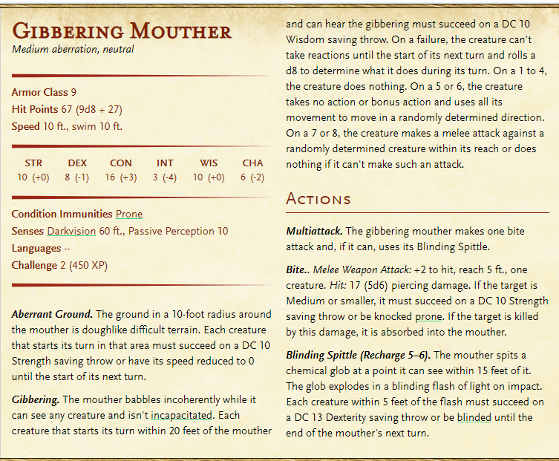

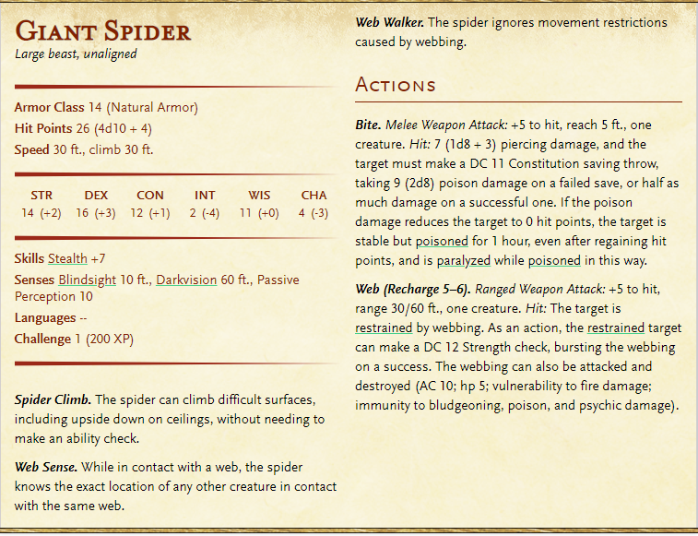

“The myconid spores are capable of re-animating the dead. It seems like a good place to start, since pure magic couldn’t bring them back…”

“The spores were unsuccessful for my needs. Although they can reanimate the dead, the creature does not show typical signs of intelligence. It is unlikely that further trials will yield better results.

Futhermore, the Myconids must telepathically control the spore servants. This is problematic as they Myconids are particularly adverse to violence and refuse to help. Even when threatened, they colony would rather die than assist.

Needless to say, I had Celestine end their disgusting lives.

We will continue looking for another form of resurrection.”

The gooey remedy is ready for use.

D20 roll to see if it is fixed.

D1 = remedy is completely unsuccessful. A separate potion can be consumed daily to stop the spread of the fungus, but it has rooted too deep into her arm. It will continue to do it’s own thing. Or it can be cut off.

D2-D6 = The spores have left permanent damage, but are removed. Disadvantage on all swings done with this arm (does not include Warhammer or other two handed weapons)

D7+ = The spores are removed permanently. Some scarring remains, but the infection will no longer affect Vahalla.

The Myconids are thankful for your help with the spiders and wish you good fortune.

# To Mount Condor

The walk to Mt. Condor is long and will probably take 2 days.

## Day 1

The walk seems tedious and uneventful. The appeal of the forest is slowly losing it’s…well, appeal.

**What do you do while you walk?**

Ex: read a book, learn a language, etc.

**What do you do at nightfall?**

As you camp, you hear strange noises way off in the distance. You are unsure what it could be. Nosaj smells something rancid, but very faint.

## Day 2 - Attack

You wake up to rain drops slowly dripping from the canopy overhead and onto your clothes and skin.

**What do you do?**

The rain collects in little puddles in the dirt of the forest. The canopy protects from some of the rain at first, but as the storm rolls in, the group is eventually drenched in rainwater. Thunder and Lightning can be heard and seen overhead.

**What do you do?**

A booming sound fills the forest. It is exceptionally loud, but not quite thunder. The smell of fowl meat is getting stronger, despite the rain and the smell of petrichor in the air.

6 zombies come limping out around you from the north and the south.

**What do you do?**

As you problem solve, a large Ogre stumbles clumsily out of the forest. You can see that part of its jaw is missing….

After killing a few, Nosaj smells a weird smell coming from Elena’s bag…. Something is inside of it.

Whoever checks on it notices the egg is hatching. It hatches for that person, but does not like Nosaj at all (because he’s a rat aka food).

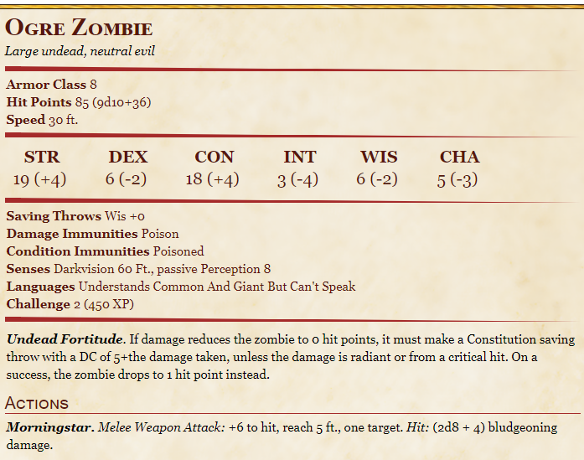

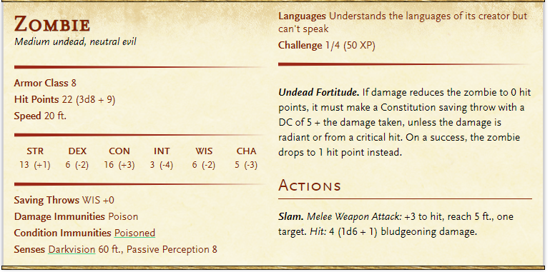

The baby owl is slimy. It doesn’t have feathers yet, but it looks as if small black feathers may be peaking out. It’s eyes are closed but it is trying to open them. You see they are the color of pale moonlight. Although it is just a newborn, it is the size of a kitten.

**What do you do?**

The already decaying bodies of your attackers litter the floor, but the distance sounds in the forest tell you that they were not alone. You are about half a day from Mt. Condor (4 hours).

**What do you do?**

You come to the foot of the mountain. The stones are slippery from the rain. You can barely make out the passage up the mountain.

DC10 dex check to see if you slip. Nothing happens. You just look like an idiot in front of the new guy.

# Mount Condor

The party arrives at the entrance of the Dwarf Community. The large stone doors would be impossible to penetrate. However, you hear some deep laughter and banter from around the corner.

Three dwarves are sitting around eating rabbits and drinking ale. They have axes near them and are wearing armor. It is likely that these are guards.

**What do you do?**

The dwarves don’t trust you, but are happy to accept any bribes you have in the form of gems, money or alcohol.

They won’t let you in but they agree to go get Thu’mer Graveden.

You are waiting outside a very long time. Like 2 hours.

Finally, the dwarves come back…without Thu’mer. The dwarves seem even drunker than before. Nosaj can smell the hoppy beer that they had been consuming.

“Thu….Thu’mer is not….here….at this time. We thank you for your….[bribe]. And *hiccup* have a nice day…”

They attempt to go back into the mountain.

**What do you do?**

The guards can’t even almost fight at the moment. They fall over drunk.

As you enter the mountain, you are impressed at the expertise of the carved stone walls. Even if you’ve seen dwarven carving before, you are always entranced by its beauty.

“HALT!” a thundering voice echo from behind you.

**What do you do?**

## Elena

### Finding Ayana and Glynvalur

“You!!!” The dwarf bellows, happily. He waddles drunkly to you. Nosaj recognizes him from the tavern-inn in Swallow’s Song!

This is Rurik. He tells you that Baern survived as well, but Harbek was lost in battle after killing a thousand of those creatures. He swears he’s not exaggerating (although he clearly is). He asks what brings you to Mt. Condor.

**What do you tell him?**

He tells you there is a beautiful Elf Maiden in the mountains, but dwarves are not kidnappers! The Elf Maiden is safe and sound with the Tiny Elfling. Seems like Mt. Condor is going to be the home to all wayward mothers!

He offers to take you to her and asks to see the ring. He wants to know if it’s dwarven quality. He scoffs when he sees it.

Ayana is as beautiful as ever; her curly chestnut hair is free flowing down her slender figure. Her green eyes are enchanted by the cooing bundle in her arms.

The elven infant is equally as beautiful. The baby has golden-copper eyes, and skin the color of pale bronze. His eyes are enchanted by his mother as he gently reaches for her hair.

The baby is Glynvalur, named after his father.

IF Nasoj is there…he can SMELL Kastor on Ayana. Almost as if he can tell that her and the baby are related to him.

**What do you do?**

She is incredibly grateful that you have come all this way just to give her the ring.

*If Elena gives her the ring, Ayana is even more grateful than expected.*She insists that her people never disliked Elena, but since Elena’s mother was so sheltering, everyone assumed there was something about Elena to be suspicious of. She tells Elena that as soon as her and her baby returns to Thels Dorei, she will speak with Elder Kastor and have him declare Elena a celebrated hero amongst the community. She will be given a pristine house in the center of the village. Ayana says “I know just the one! You will love it!”

Additionally, she tells you that those demons are back in the forest. She was still with child when she ran into them. They were marching from the east and it seemed they were combing the forest for something, because she couldn’t find a way around them. They pushed her so far west that she ended up in the mountains. As two of them attacked her, Rurik and Baern we’re coming up from Swallow’s Song and were able to rescue her! If it hadn’t been for them, her and her baby would have been lost.

She asks Elena to stay with her until she and her baby are strong enough to make it through the forest.

Ayana says her and the baby need rest, but thanks you profusely for your service. The dwarves rush you out of the room.

## Vahalla

The dwarves seem to like you based on Rurik and Baern’s embellished description of your fight with the undead. Apparently, your small party managed to kill a dozen wraiths.

**Do you want to correct them?**

They invite you to dinner in the Mountain Hall. They are determined to get you fat and drunk, constantly putting more and more food on your plate and refilling your drinks constantly.

The dwarves that are not from the southern mountains, **Sandstone**, are weary of Vahalla since they know Tieflings have been causing issues for their brothers. But the few dwarves that are from Sandstone, including Rurik and Baern, are happy to accept Vahalla; they know not all Tieflings are bad.

You feel surprisingly welcome amongst the dwarves. They say they’ve never met a Tiefling that wasn’t good at something, and they’d reckon you’re a pretty good fighter. They ask if you want to stay and protect the forest with them for a while.

## Nosaj

### Thu’mer Graveden

A sudden weight comes crashing down on Nosaj’s shoulder, almost knocking him off his seat. A slightly taller, red-bearded dwarf stands strong next to your party.

“Brother!” The dwarf bellows! “Brother!” The rest of the dwarves echo, slamming their goblets down on the stone table and chugging the rest of their drink.

The red-bearded dwarf shakes his head humorously at the other dwarves.

It is Thu’mer Graveden, the strongest and bravest fighter the dwarven race has ever seen (or so he claims).

**What do you do?**

After some chatting, he askes if you’ve seen Raeya.

**DC Int Check 10: Under 12 – no memory.**

Barely Remembers: She was visiting Arynsport, where Nosaj grew up and where the fighter’s guild is. They had a fling for a summer before. This was not that long ago, maybe slightly under a year and a half ago. She was pretty, but her ferocity and wildness is what drew him to her. After a whirlwind romance, she left the city without a word.

When Nosaj says he hasn’t seen her or talked to her, Thu’mer grows very quiet. He takes a long hard look at Nosaj. “She’s here,” he says solemnly. “You should go see her. Not now. In the morning,” he pauses and looks at your companions “it’s probably better to go alone”

For now, let me show you to your rooms.

He shows your party their rooms. Although they lack the comforts of the Silver Vine Inn, it’s better than sleeping on the floor.

### Raeya and Arys

When Nosaj enters the room, Raeya is brushing her hair. She turns gracefully as her door opens. She seems unsurprised that it’s you, and a weak smile spreads across her face.

**Did you want to say anything?**

“Hello, Nasoj,” she whispers sweetly. “I heart a beautiful, blonde half elf arrived here yesterday. I wondered if it was you.”

She silently waits for your response

**What do you say?**

Talk about how she traveled across the mountain pass with a Talos priest when she left Nasaj in Arynsport. The priest took her all the way to Silver Rose.

**If you ask what brings you here**

A quiet cooing sound fills the room from behind a hanging curtain.

**What do you do?**

It is a baby girl. She has blonde hair and electrifying blue eyes. Although she has human features, something about her feels like she has elven heritage.

**What do you do?**

This is Arys. She’s my daughter.

**How old is she?**

7 months.

**What do you want to do?**

She came to Mt. Condor because she knew you and Thu’mer were friends and he was the only one of your close friends that she knew from the fighter’s guild.

She’s been passively looking for you, but mostly, she just wants a safe space to raise her baby. The dwarves have been very accommodating.

She asks if you’d like to stay for a while with her and the baby.

### Wererat

A dwarf tells Nasoj that Raeya is looking for him. The short walk to her room is exhausting for him. He leans on his wall, short of breath, sweating through his clothing. He feels like his body is on fire but wants to make sure Arys is ok.

Night is falling and Raeya is standing outside with her baby. She’s looking at the full moon and asks Nasoj if he’ll start teaching Arys Elvish.

An overwhelming smell of the mountains floods Nasoj’s senses. A searing pain radiates through his entire body. An uncontrollable rage takes hold in his mind. He is fighting the urge to attack Raeya. Her keen senses and protective instincts kick in and she is able to dodge an grabbing attack from the half elf. As he looks down at his hands, Nasoj is confused to see fur and sharp claws. He remembers nothing else.

Nasoj awakes in the dwarven infirmary. He is shirtless and bootless, and his pants are torn to shreds. He is incredibly sore. The room empty

**What do you do?**

They tell you that you attacked Raeya and the baby, but Raeya was able to get out of there safely. You looked to be a giant rat, standing on two feet like a man. Had it not been for your clothing, the dwarves wouldn’t have recognized you and killed you. They ask what happened?

**What do you do?**

Raeya won’t see you nor let you see the baby. She is very upset.

## Other things to do in the mountain

It seems that Mt. Condor may be a place you can call home, at least for a while. There are many things you can focus on until you want to leave. What would you like to practice/learn?

There is a library but most of the books are in dwarvish.

You can learn basic artesian crafts: Brewer’s, Jewelers, Smith’s, Masons,

You can learn a language (from books or from other travelers)

Drink and learn things: Old Mt. Condor, Medusa Lore,

Ella and Kallista show up. They are looking for a Talos relic for Toaba.

## Optional Battles

### Stone Giant

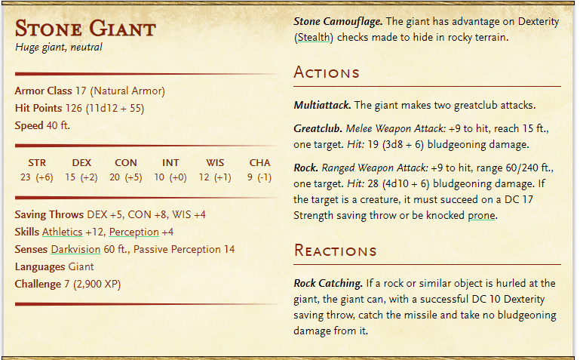A stone giant has become lost in a cavern. The dwarves think he may have found a passage in through the underdark, but it collapsed recently while they were mining. The Giant is now trapped and feeding on rats. This wouldn’t be a problem but he’s trying to get out and is compromising the integrity of the mines. He is incredibly strong. **Thu’mer will go with** **you.**

At some point the giant hits the wall and 100 pieces of Moss Agate (50gp each) comes flying out of the ceiling.

### Temple of the Stone Men

You hear a rumor or read in a book about a place that in the mountains is the home to a Magical Item. This item in the possession of a humanoid creature will allow them to control a Vampire. In the possession of a Vampire, it gives them immunity to radiant damage (including sunlight) and acid damage due to running water.

The journey down to the temple is long and dangerous. The walls have not been excavated in at least a thousand years, so although there is a path, stone has begun to crumble and fall in your path.

You can hear running water passing through the mountain.

After hours of searching, you come across what appears to be a tomb door. The door has a carving of a dozen snakes, their tails all tied together in a ball.

The heavy door is able to be pushed open (DC strength 12). The room is dark and dank. The remnants of torches dot the walls. Lighting the torches illuminates the room (can’t see back wall unless torches are lit or if you are super close). The room is plain with three exceptions.

1. There is an open tunnel to your left.
2. There is an elevated platform in the center of the room. On the platform, there is a pedestal.
3. On the back wall, there is a painting of a large stone door.

**What do you do?**

When you walk up onto the platform, which is really only big enough for 1 person, you see the pedestal has a stone platform on the top with an imprint of a left hand.

The painted door is just a painted door. There is nothing interesting about it, except that it is a painted door in an old tomb. The door also has snakes painted onto it.

The other hallway is also incredibly dark, but has old torches in it.

**What do you do?**

If you attempt to put your hand on the handprint, the stone begins to come alive. As you lower your hand, the stone imprint either expands or contracts to match your hand…The imprint is slightly too large though, by maybe 1/8 of an inch all around. Nothing happens.

**What do you do?**

There are a few other rooms in the area. One room seems to be stone statues of warriors battling. They look incredibly life-like…

Another room is completely empty, but has snake skin littering the floor. It looks as if there may have once been wooden furniture in the room, but it all has decayed past the point of usefulness. It doesn’t appear anything is in there.

Another room has a corpse laying face down on the floor in the middle of the room. Not a skeleton, but a corpse. The dress it is wearing appears to be female. The skin is slightly blue in color, but more blue than Elena. Her hair looks like it has been bundled into locks and wrapped in snake skin. There is a stone door to your right.

The creature gets up. Both of her eyes have been forcibly removed.

DC arcana 10 to recognize Medusa.

You can avoid the battle if you can get through the door.

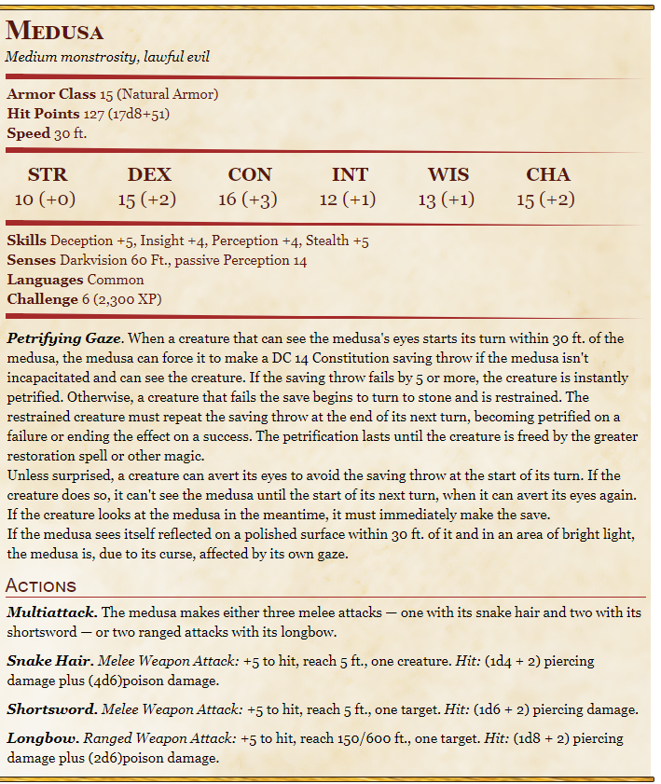

**What do you do?**

The room is dark with a pedestal on a platform again. It looks similar to the one in the front room. On this pedestal, there is not a stone template. Instead, there is a stone basin with a medusa head at each of the corners. The eyes are pouring blood into the basin, which is completely filled to the brim with the warm, red liquid. You can vaguely make out a handprint at the bottom of the basin. Other than the standard torches, there is nothing in the room.

**What do you do?**

When you put your hand in the blood and place it flat against the bottom, your hand starts to burn like fire. When you pull it out, you see it has been encrusted by stone. You cannot move your fingers.

Get back to other pedestal and the stone hand now fits perfectly. The painted door begins to crack and changes into a real door.

Behind the door, you see a golden scepter. On it, a tiny carved vampire is bowing to a man holding the scepter. There is also 100gp

**Why does it do either or:** A Hag made a deal with a vampire hunter that she would help him conqueror his fears. But if he ever lost her gift, she’d give the power to his enemies. Long story short, he was dumb and the vampire slave he’d taken murdered him.

### Talos Clock

Ella said that she is going to go uncover a Talos relic for Toaba. You must go way north into the mountain to find it.

It is hard to find the entrance.

When you do, it is another puzzle. You can see the relic at the back of the room, but it is protected by magic.

There is a light coming through the ceiling through a crack in the mountain. IN the center of the room you see 12 pedestals with stone tablets on them.

If you turn them over, they have the word of the number written on them “seven” not “7”

They are in clock order.

There is a scroll that reads

“Flip tablets of three then make the light 3:33”

**Solution:** Flip the 4 tablets that have 3 letters in name (one, two, six, ten) (optional turn over “three”). Then stand in the center and put your shiny arms or weapons at 3:33 time.

Relic necklace is uncovered.

# Back to Thels Dorei

It has been 6 months since the party arrived at mount condor. The attacks by the undead have stopped.

Arys has celebrated her first birthday and is running around the mountain halls carefree.

Glynvalur is a little older than 6 months and although he cannot talk, he seems to understand elvish, dwarfish and common. He babbles proficiently in all 3 languages.

Optional: The great owl hoots at him when it is around a Glynvalur seems to understand that too. He will also hoot back, and the owl will do things for him (i.e. get toys off of high place).

Nosaj has learned how to control his lycanthropy and doesn’t turn out of will. He can even shapeshift into a giant rat now, rather than just the hybrid form. His sense of smell is impressive even to animals.

Nosaj and Raeya have a very good relationship/love/whatever.

Ayana has become the sister Elena never had.

Despite their differences, the dwarves have inducted Vahalla into their world and treat her like a much taller skinner dwarf.

Ayana and Raeya have begun to worry about the well being of their children, however, growing up in the mountains. Although the agree that it is a wonderful and safe place, their children’s elven blood would soon crave nature.

Ayana asks Elena if she will go back to Thels Dorei with her.

Raeya asks Nosaj if they can go back to Silver Rose or Arynsport.

Thu’mer wants to go too

**What do you do?**

The walk to Thels Dorei is plesently uneventful; Traveling with 2 very young children is difficult enough without a zombie attack. The city of Thels Dorei is as beautiful as when you left.

Ayana’s family greets the group eagerly; Elven scouts must have seen them coming. They flock to her and the pointy-eared child. Ayana explains how Elena had fought to bring back Glynvalur’s (her dead lover, not the child) ring. She tells how Elena spent the last half ear keeping Ayana company and safe. She asks Elder Kastor, her great great grandfather, if Elena can re-join the community as a celebrated member. He reluctantly agrees.

**What do you do?**

Kastor give the reward

* Staff of the Python (Druid, Cleric or Warlock only) (requires attunement)
  + Throw on ground and will turn into Giant constrictor snake
  + Must say command word
  + Mentally command snake within 60 ft
* Javelin of Lighting
  + When thrown and say command word, it turns into into a lighting bolt up to 120ft.
  + Javelin damage + 4d6
* Bracers of Archery
  + Gives proficiency in bows
  + +2 to damage rolls with archery weapons
* Manual of Bodily Health
  + Talks about health and diet tips
  + Read for 48 hours within 6 days or less and Const score +2 (not mod)
  + Maximum for Const +2 (not 20 anymore, but 22)
  + Loses magic but can be reused in 100 years.
* 50gp (all they have)

**Elena has a choice to make. Will she stay with Ayana or will she go with the group back to Silver Rose.**

**The rest may stay the night or begin their hike to Serenity Gardens. It is nearing night fall.**

# Back to Serenity Gardens/Mansion Reprise

ONLY IF THEY GOT THE MEDUSA SCEPTER

The beginning of your walk looks the same as the last few days.

As you march south, the forest becomes darker and colder.

**Play Spooky Waltz**

The forest is eerie. Despite having walked through it for days and explored parts of it while in Mt. Condor, it begins to feel like you’ve left the Temporal Forest altogether. The trees are the same, the roots are the same, the sounds are the same. But something is different.

**What do you do?**

A low cold mist begins rolling in around you….

**Let them shit themselves**

The familiar graveyard appears in front of you. The mansion, despite having been lit on fire at your last visit, stands timelessly strong.

The cemetary has grown larger.

Taylor DC 10 perception check => you notice the gravestones have your name on it. All of them.

The dancing lights (will-o-whisps) are still dancing around the cemetery. The door to the mansion lies open before you.

**What do you do?**

**Play meet the vampire**

Jade is waiting inside the main hall. The suits of armor guarding the entrance watch you as you pass but remain at their posts. The paintings still hang on the wall, but their occupants have left.

**What do you do?**

Jade cant’ take her eyes off Arys. The blonde child is obviously Nosaj’s.

Her deceptive and playful smile shoots daggers through the room. Raeyna who is holding Arys instinctively falls behind Nosaj.

“Pretty baby. Do I get one too?” Her flirty comment test’s Raeyna’s control. Raeyna is pretty, but not as pretty as Jade.

**Banter**

“I’ll keep this short. You have acquired an artifact and I have come to purchase it from you.”

* 5000gp OR
* 1 magic removing potion – capable of removing stone from hands
* 1 curse removing potion – capable of removing Lycanthropy
* 1 Dragon egg of any color

**What do you do?**

The (rest of the) walk is exceptionally uneventful. Part of you may have been wishing for more adventure.

**What do you do?**

The small village is vacant. The once beautiful flowers and vines have decayed and have become brown and withered. The pleasant smell of food no longer lingers in the air. The dock leading the pond has crumbled and fallen into the pond. The water is filled with mud. There are no people and no skeletons around.

**What do you do?**

The visitors lodge isn’t well taken care of this time, but the 2 bunk beds are still intact.

**To Pixie Garden**

As you continue down the path. You see the familiar scene of flowers. About 2 hours in you start to see rosebushes of usual size. You remember you are about 2 hours away from the Rosemar patch.

**What do you do?**

As you approach the Rosemar patch, a bright light comes whizzing at you!

It stops dead in front of Nosaj and begins screaming in the most high pitch voice you’ve ever heard. You have no idea what the Pixie is saying

“HELP!!!” It yells in a slightly lower tone angrily. It grabs Nosaj by his hair and starts pulling him. Although she couldn’t move him by herself, he notes that she is surprisingly strong from being 6 inches tall. She is pulling him into the flower patch.

**What do you do?**

She brings you to the site of a massacre. As you look down, there is a large clearing, maybe 75ft in diameter filled with tiny houses made of clay, toadstools, leaves and sticks. Pixie bodies are littering the streets and Tarantulas and normal sized rats plague the town. You see pixies with twig spears poking the eyes of the spiders.

Their tiny high pitch screams of pain makes your ears ring.

“They are immune to our magic!” Basil yells. “Help us!” She dive into battle, pickup up tiny rocks and throwing them at the rats. The rats barely seem to notice.

**What do you do?**

The pixies are battle worn. The look around to see their lost brothers and sisters. It is a tragic moment in the fey community.

**What do you do?**

Basil is curious about Arys and lands on the little girls knee. She says she looks like Nosaj. Arys is delighted by Basil and reaches out to grab her. Basil is too fast to be caught but doesn’t mind playing with the human baby.

“Basil!” A high pitched but distinguishably male voice calls out. “BAAASIIIIL!!”

“Styx!” Basil yells back. A tiny light comes flying in at high speed and tackles Basil. As the light fade, you see a brown pixie, about 8” tall holding Basil like his life depended on it. Basil is crying tears of joy. They start speaking in a language you don’t understand but you can tell they are happy to see each other.

**What do you do?**

They tell you that something is happening in Feywild that is causing the animals to try to cross over.

They ask if you’d be willing to help. They tell you there are a lot of rare things in Feywild that most adventures don’t get to see. Reaya and Arys can stay in the Pixie Garden if they want. Other than the rats, they haven’t had any issues. Thu’mer decides to stay too, because he doesn’t have any desire to go to a “floofy faery land”

**If you decide to go, you go in through the mushroom patch**